%BUTTERWORTH IIR LPF

%Performed By: Sonu Sharma T2b 630

Ap=input('enter the value of passband gain Ap :');

As=input('enter the value of stopband gain As :');

ohmp=input('enter the value of analog frquency ohmp :');

ohms=input('enter the value of analog frequency ohms :');

T=0.1;

[N,CF]=buttord(ohmp,ohms,Ap,As,'s');

disp('Order of filter is:')

disp(N)

disp('Cuttoff frequency is')

disp(CF)

[Bn,An]=butter(N,1,'s');

[B,A]=butter(N,CF,'low','s');

Hs=tf(Bn,An)

HSU=tf(B,A)

[N,D]=bilinear(B,A,1/T);

Hz=tf(N,D,T)

w= -pi: 0.01:pi;

Hw=freqz(N,D,w);

mag=abs(Hw);

plot(w/pi,mag,'k');

xlabel('frequency');

ylabel('magnitude plot');

title('butterworth digital IIR filter');

grid

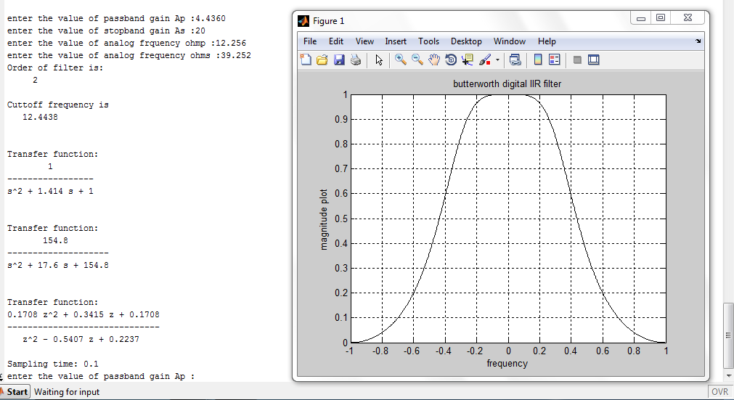

%BUTTERWORTH IIR HPF

%Sonu Sharma , EXTC B, Roll.No.630

Ap=input('enter the value of passband gain Ap :');

As=input('enter the value of stopband gain As :');

ohmp=input('enter the value of analog frquency ohmp :');

ohms=input('enter the value of analog frequency ohms :');

T=0.1;

[N,CF]=buttord(ohmp,ohms,Ap,As,'s');

disp('Order of filter is:')

disp(N)

disp('Cuttoff frequency is')

disp(CF)

[Bn,An]=butter(N,1,'s');

[B,A]=butter(N,CF,'high','s');

Hs=tf(Bn,An)

HSU=tf(B,A)

[N,D]=bilinear(B,A,1/T);

Hz=tf(N,D,T)

w= -pi: 0.01:pi;

Hw=freqz(N,D,w);

mag=abs(Hw);

plot(w/pi,mag,'k');

xlabel('frequency');

ylabel('magnitude plot');

title('butterworth digital IIR filter');

grid

